Requirements Analysis:

1.No effort on UI components.
2.All of the scenarios pre-entered through code is fine but output should be displayed.
3. Exercising Unit tests across the code should be great.
4.Completed program should be able to calculate the best possible discount for any collection of Pokémon.
5.Each and Every test scenario should be translated into unit test case. Additional Unit tests are encouraged.
6.Coding Practices Should be maintained before the delivery of the product.

Requirements Estimation:

Activities Achieved Spend Effort

Requirements Analysis - ¼ hour
Brainstorming - 1 hour
Design - ½ hour
Development - 2 days
Coding Practices - ½ hour
Junit - 2 hours
Testing - 2 hours
Release Notes - 1 hour

Development Effort Scenarios:
- Finalizing the JAVA console window in making the product selection
- Handling Exception Scenarios
- Implementing the logic with Maps
- Maintaining the whole transaction by executing the Maps.
- Following coding practices like cyclomatic complexity, commenting the code, naming convention etc…
- Displaying the result
- Developing the code for junit test cases and evaluation of all the test cases.
Testing:
All Default test case scenarios are tested from end to end. Please find the screenshot below.
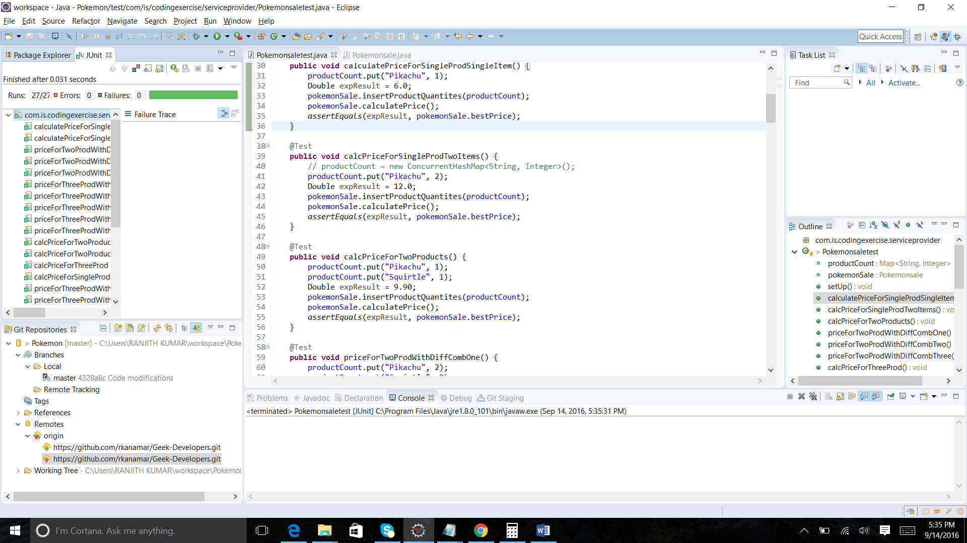

Execution of the Problem Statement:
1.Application launch provides the below console
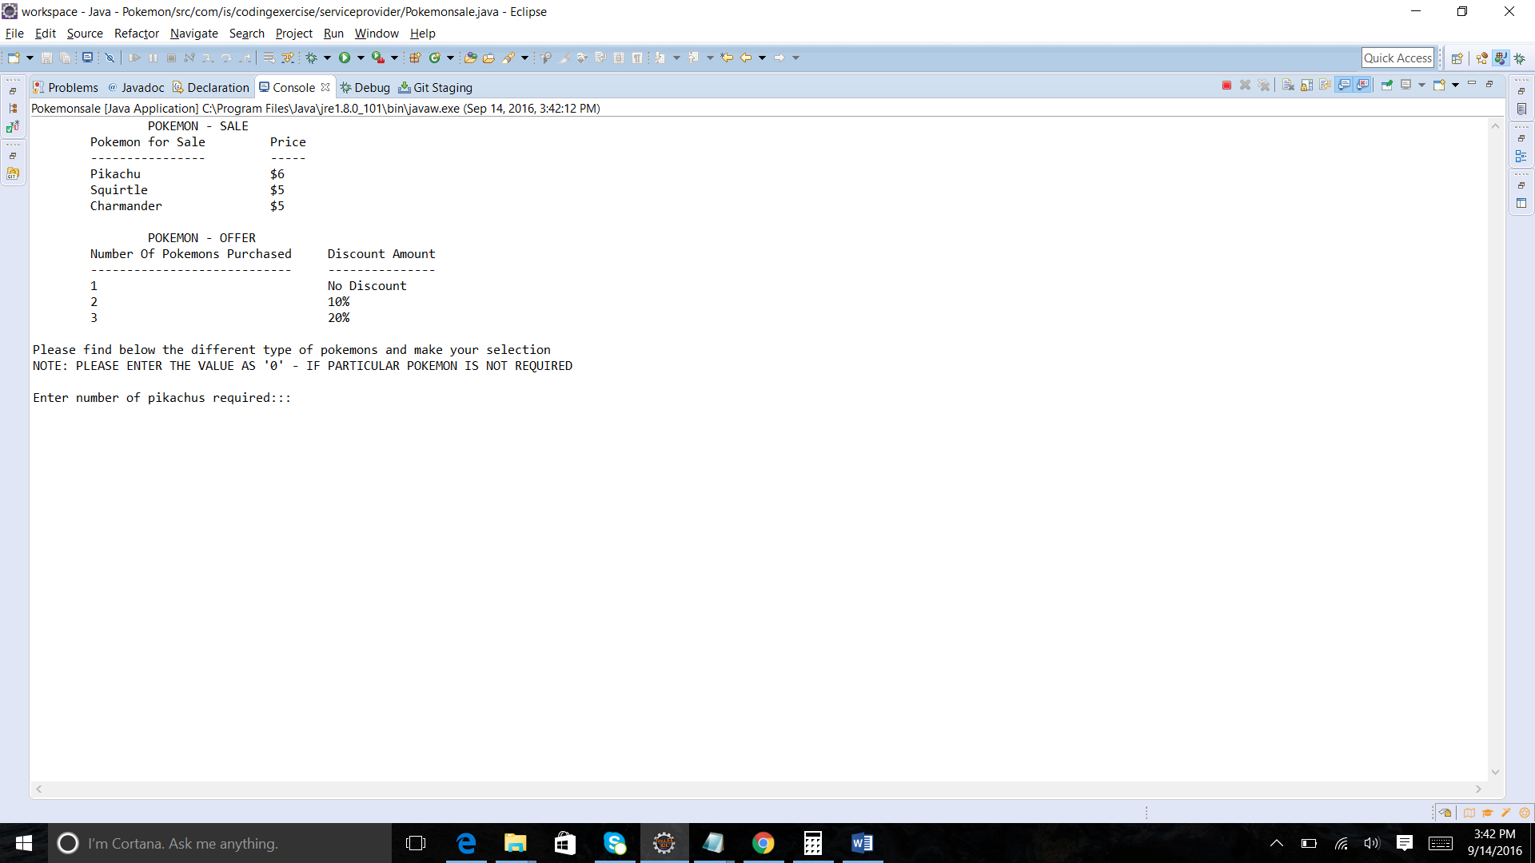

Above Display provides the Pokemon information and its discount policies by prompting us the required number of pokemons suggesting the instructions in providing the input.
2.Application will give option for the user to enter the amount required for his selection otherwise he can enter zero. Please find below the screenshot for the user selection.

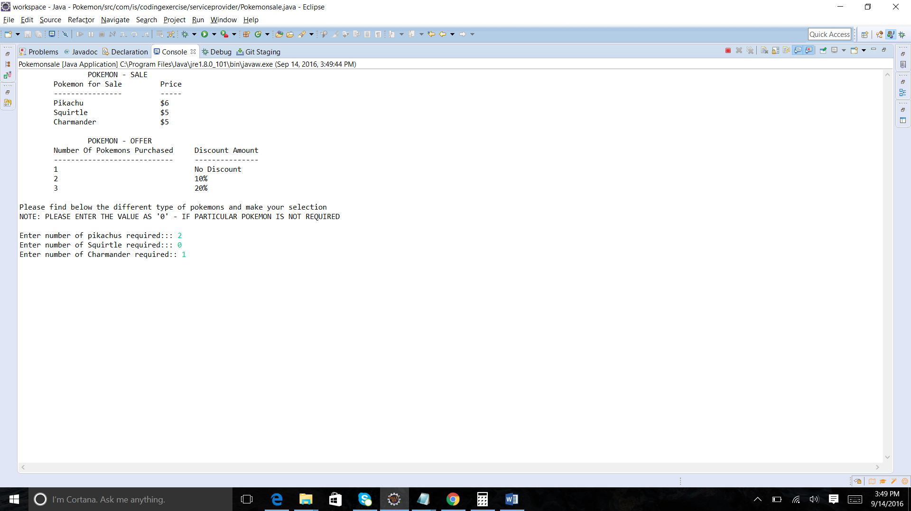
3.Application shows the best price calculation based on the user selection. Please find below the screenshot.

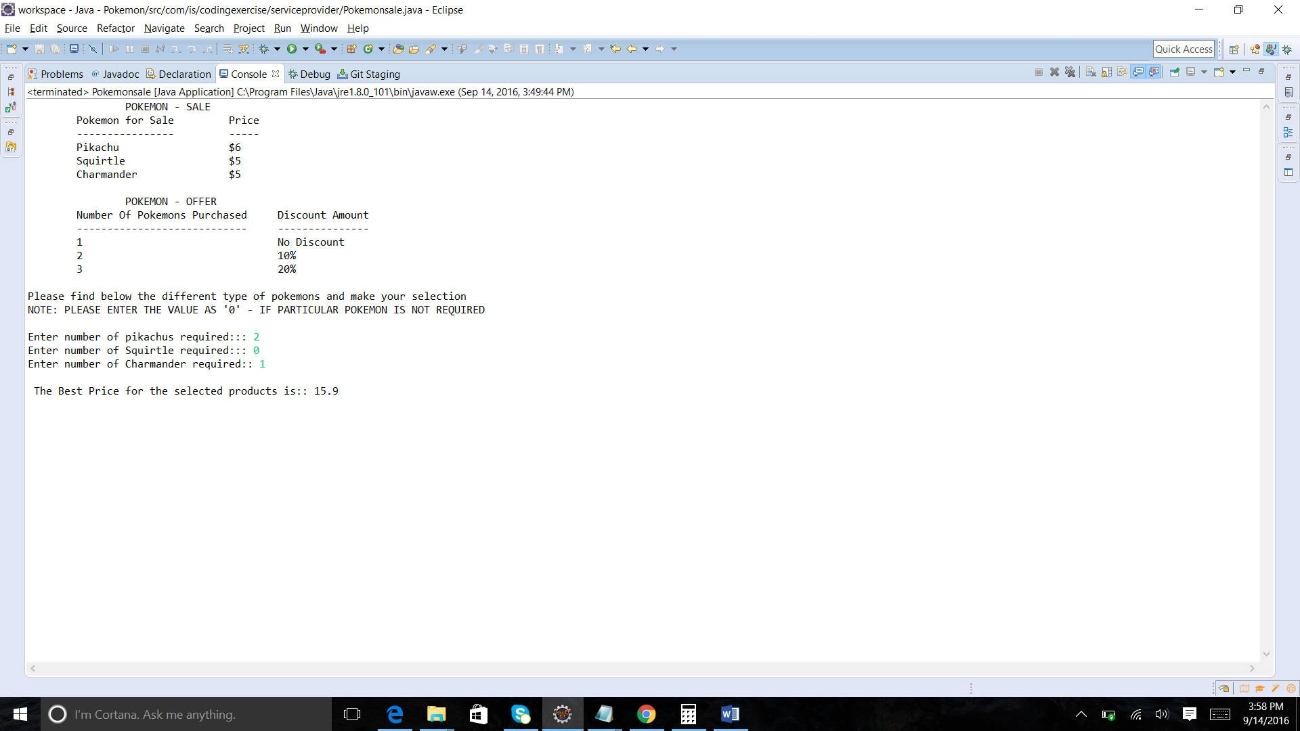

Exception Scenarios: -
1.If user enters negative values or any other values than positive integers then application will throw
Invalid Input – Please enter valid input.
Please find the screenshot below.

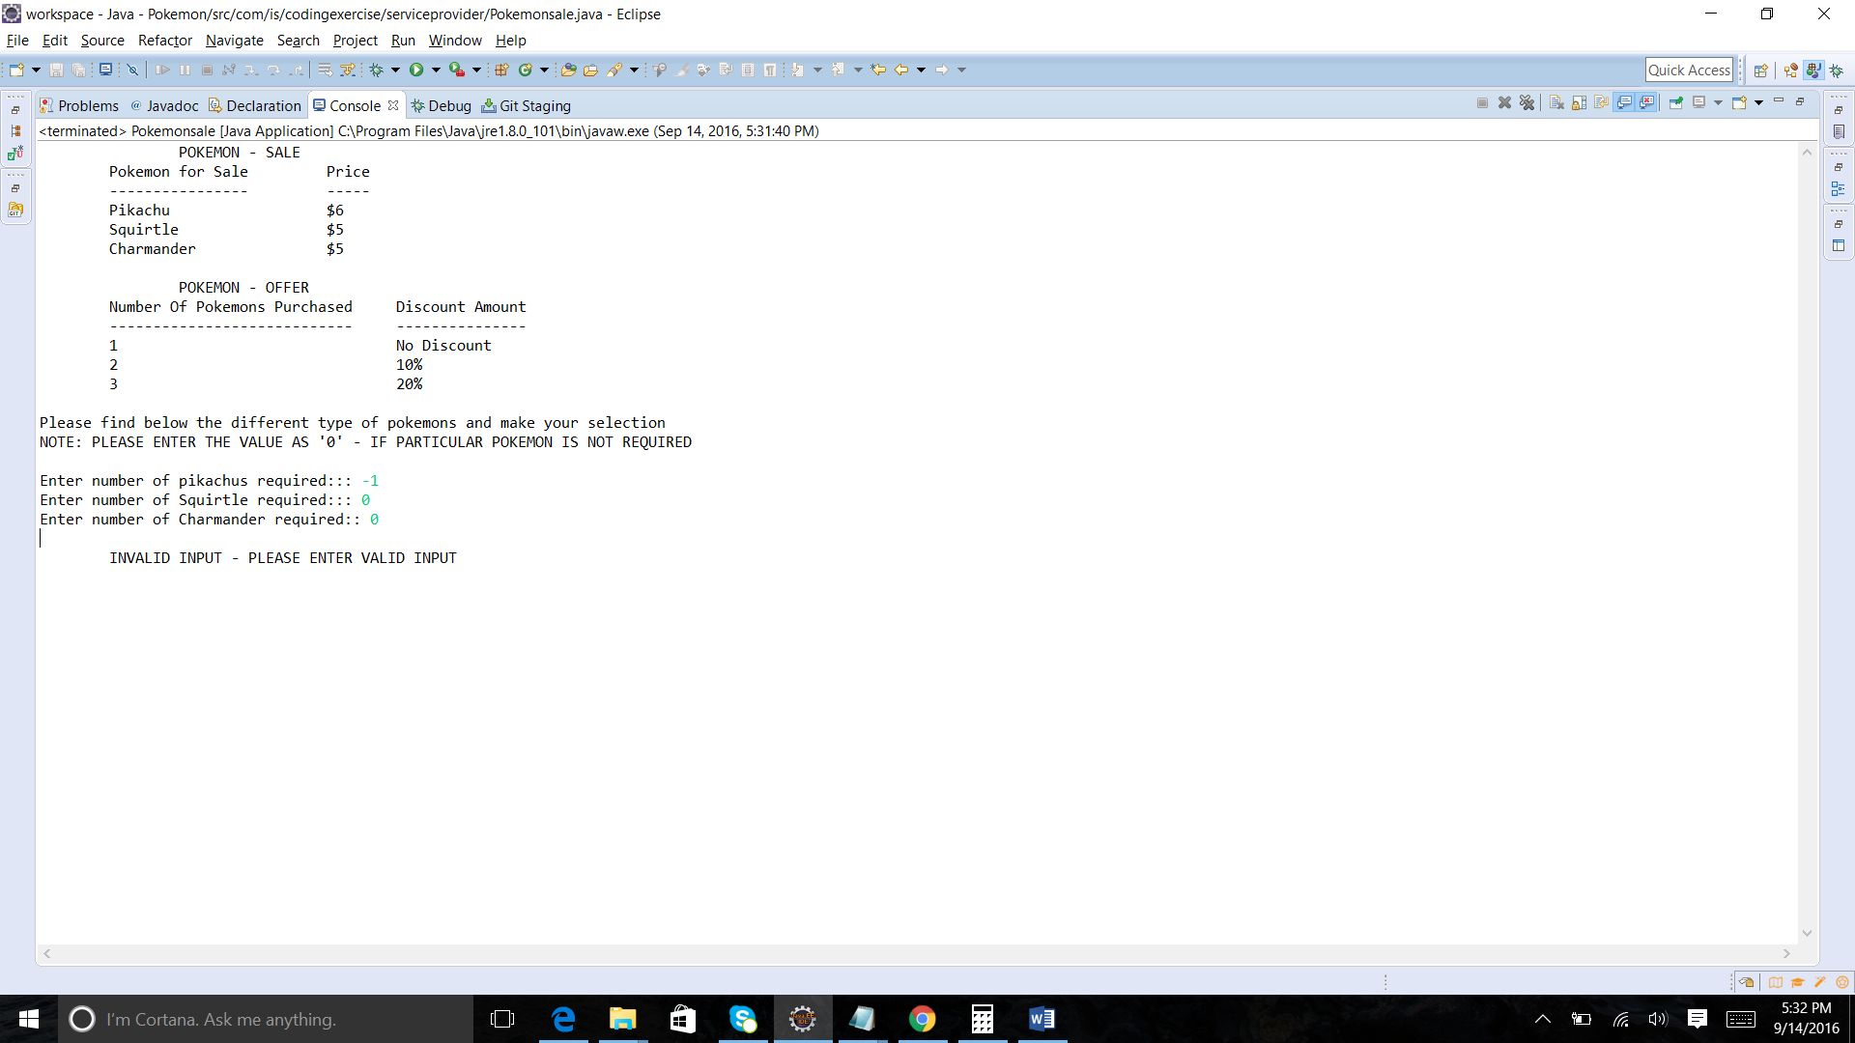

2. If the user enters String values than positive integers then it will throw Invalid Input – “Please provide valid input” error. Please find the screenshot below.
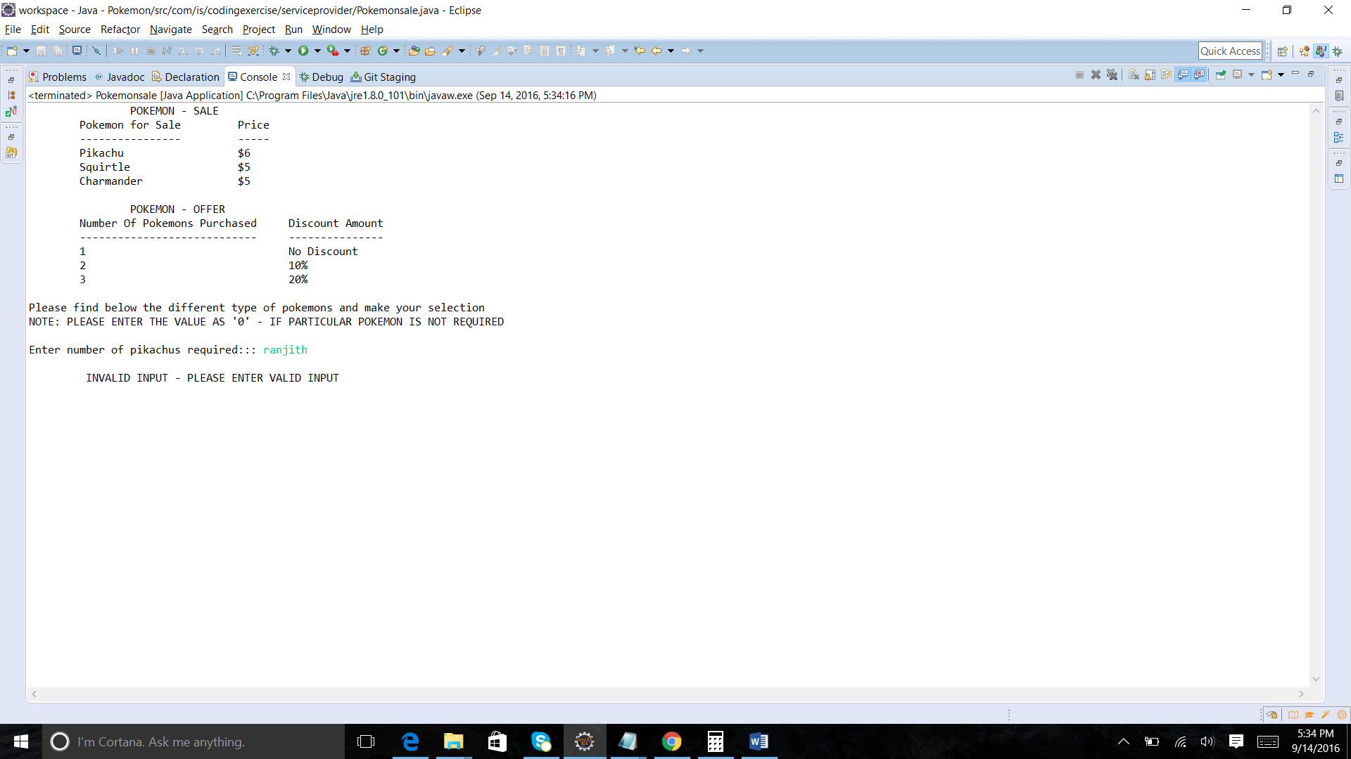

Project Package Structure:

